|  |  |
| --- | --- |
|  | **Masterspace Solutions Limited** |
| ***Tangible Solutions for Businesses*** |

**Progress Report**

***For***

***Integration of KenloadV2 in All Axle Load Facilities in Kenya***

***On***

***Project:*** *Upgrading of Kenload Weighbridge Management System Software to Kenload Version 2, Integration and Rollout to all the Static, Virtual And Mobile Weighbridges*

Contents

Introduction 2

1 Successful delivery and installation of WMS 2

2 Rollout in all Weighbridges 3

3 User Acceptance Test for Processes and workflows 3

*4* Module Training of users and administrators 3

*5* Successful Migration of the existing data on the deployed system modules 4

6 Next Steps 4

# Introduction

Upon completion of the upgrade of KenloadV2 system, Masterspace Solutions embarked on the rollout and integration of the new system to all the KeNHA axle load control facilities in Kenya. The exercise was categorized into four areas of *successful installation of WMS,* *rollout in all weighbridge stations*, *training of users and administrators,* *acceptance tests, and successful migration of existing data to installed modules.*

This report presents the achievement made on each of the items to bring up and understanding on the general progress of the projects.

# Successful delivery and installation of WMS

A Weighbridge Management System has been developed and installed at the Kenya National Highways Authority (KeNHA) headquarters. The role is to provide a centralized interface to access information on the axle load control facilities in the country and ensure that common services like tagging are pushed and made visible in all stations.

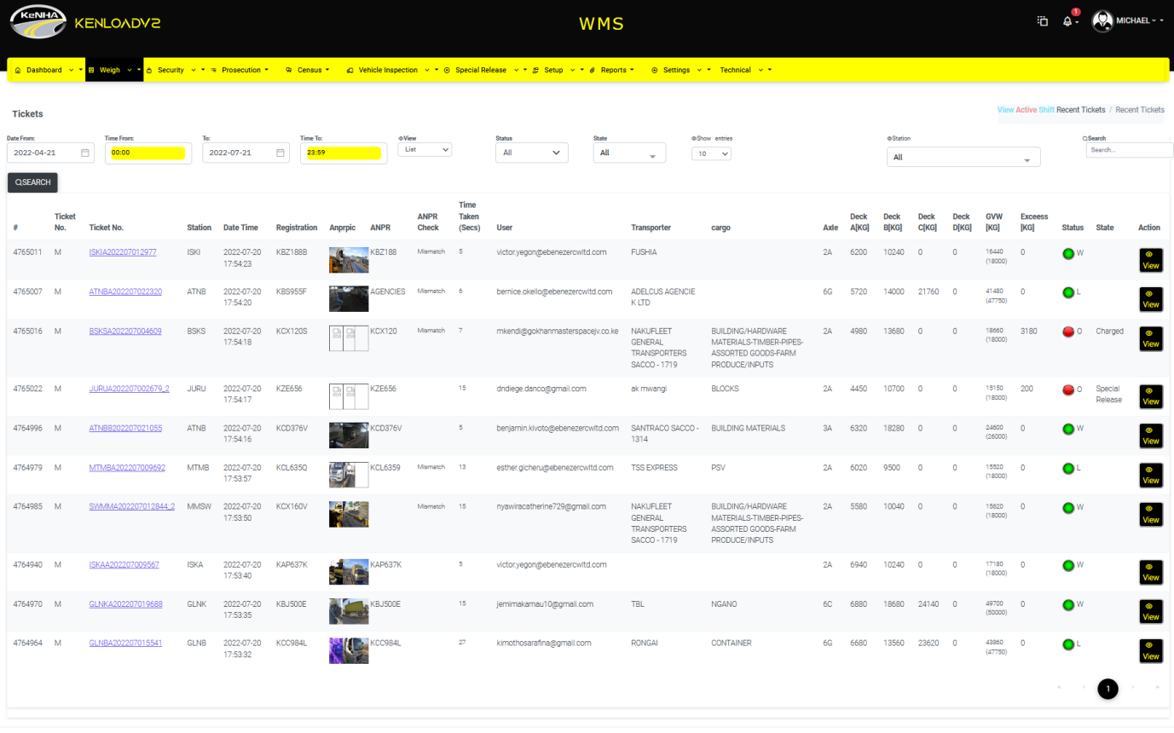Through the WMS, tickets for all the weighbride stations can be viewed. The access to information provided for in WMS is through a web interface. Below is a snapshot of the components provided for in the

# Rollout in all Weighbridges

Based on the ToR, KenloadV2 system has been developed and rolled out in all the following weighbridge stations.

1. Athi River
2. Gilgil
3. Mariakani
4. Miritini – Ndongo Kundu
5. Mtwapa
6. Webuye
7. Juja
8. Isinya
9. Suswa
10. Busia
11. Rongo

The upgrade focused on automatic tagging system to ensure that tagged vehicles can be apprehended when noticed in other facilities, excellent reporting, easily accessible web based system. With a possibility to perform audit logs.

As of today, the scanning of permit has greatly improved thus providing quick service for both SACCO trucks and wideload vehicle inspection. We also have system generated invoicing that scales down on complaints and human related errors during computation of charges.

A few tasks are however still in progress that includes integration of financial management into the system and virtual tag integration to with multideck scales.

# User Acceptance Test for Processes and workflows

User acceptance test was done on 23rd March, 2022 at the Athi River piloting stations. This informed the kick-off of rollout on all weighbridge stations. Individual sign-off from all management contractors is in progress.

# Module Training of users and administrators

Training of users and administrators were conducted along with the rollout to allow for smooth adaptation of the system. Currently the team have been trained and embraced the system fully. Online support is being provided for challenges that arise. A follow up per cluster training shall also be offered.

# Successful Migration of the existing data on the deployed system modules

Previous weighbridge management software was made up of installations on KenloadV1 and Kenwei. These had their separate database definitions and storage. With the upgrade it was important to push the historical data to the new database system. This not only improved on quick reference for historical data but presented a uniform presentation of reports. The exercise of migrating historical data to KenloadV2 database is already completed.

# Next Steps

The next steps are to refine on financial integration with KenloadV2 and perform joint acceptance in all axle load facilities.